Friends of Mont a l’abbe School
AJC 339
Sensory Trolleys

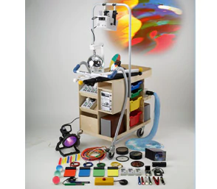

We were delighted to be chosen as one of the charities to be receive a 50@50 award in the 50th Anniversary year.
We are in the process of helping with the funding of the New Sensory Room with work commencing summer 2022 and this amazing award of £10.000 has helped us to purchase 2 versatile and mobile sensory trolleys which is an invaluable piece of equipment and resource that can be used anywhere in the school too not just in the sensory room as a stand-alone unit. The Trolleys place function and versatility over the aesthetic and the effects and functions that these pieces of equipment have. can be used with all students with special needs aged 3 to 18 that attend the school.
These pieces are designed especially for the requirement that are needed by the students

Once we receive them, we would welcome everyone to come and view these marrowless pieces of equipment in the new sensory room

Thank you for helping us help children who face special needs

